The Gibler Family on Red River

Clinton Edgar “Clint” Gibler was born 1 Sep 1890 in Claflin, near the center of Kansas. His dad, William Edgar “Ed” Gibler, had left home at 12 and wandered the west for a few years before marrying, but by 1890, Ed and his wife Sarah were sod-busting in southern Kansas and living in a sod house.

Clint was an identical twin. He and his brother, Clifford, were born prematurely and together weighed only five pounds at birth. Their mom kept them together in a shoebox packed with cotton during their first months. Unfortunately, Clifford died at the age of 11 months.

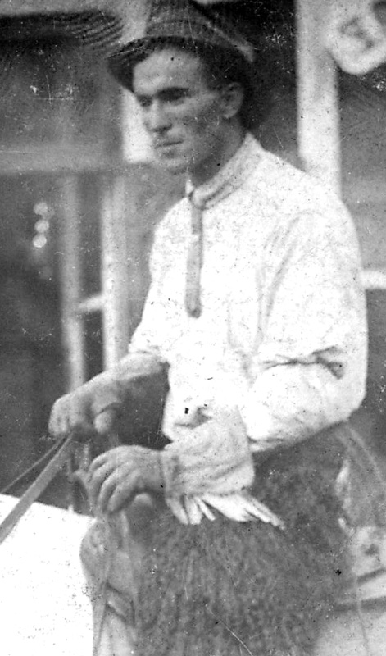
Times were tough in Kansas. In fact, Clint’s grandmother starved to death there because she gave a lot of her food to the rest of the family. By 1898, Ed and Sarah were thinking more and more about the lovely land in Idaho County, “free for the taking,” described to them by two of Sarah’s uncles, named Newsome, who had come here during Idaho County’s first gold rush. Pretty soon, they called it quits in Kansas and gave their homestead to Ed’s brother Clint. Then Ed, Sarah, and their surviving children, eight-year-old Clint and five-year-old Edith Mae, came west to Idaho County, where they bought property in Pleasant Valley, near Clearwater. Almost immediately, another child, Delbert, arrived. Some years later, two more children arrived -- Clarence and Mildred.

Clint went to school only through the fifth grade. At the age of 12, he started working for Nate Pettibone, who owned the Stites-to-Elk City Stage Line. The stage took several days to make the run when the weather was good, but in winter it could take as many as 11 days. Clint learned a lot from Nate, and by the time he was 16, he had his own team and freight wagon. He was in business for himself.

Clint had a favorite horse, an albino named “Klondike.” Klondike knew a lot of tricks, and Clint enjoyed putting on performances with him. For example, Clint would ride Klondike up a few steps of a ladder. (Clint’s dad, however, didn’t ride horses; he always walked, even long distances.)

As he approached manhood, Clint must have felt that he had it made. He was strong, handsome, independent, friendly, and making money. The quartz gold boom was just reaching its peak in Idaho County, and the future must have looked good.

Mabel L. Wren (originally named Lillie Mae Wren, like her mother) was born in Siloam Springs, in the northwest corner of Arkansas, on 19 Dec 1895. However, her mother died when Mabel was only six weeks old, and then her father -- James Milam Wren -- left home. Mabel was then taken in by her grandparents, Joseph Marion Winfield and his wife Martha, but Martha soon died, so Mabel was raised by her grandfather Joseph and two teenaged aunts, Mary Jane and Oma.

By 1910, the family had moved to Stites, Idaho, where one aunt, Mary Jane Winfield, married Robert F. Baldwin. Mabel didn’t much like school in Stites, so she quit and went to work in the Commercial Hotel. She was 14 years old.

Mabel met Clint Gibler when she spilled soup on him in the hotel restaurant. She said later that her first impression of Clint was that he was too wild for her; he was always going out with lots of girls. However, they kept seeing each other in Stites, and one thing led to another. Four years after she spilled the soup on him, Clint popped the question. Mabel’s engagement ring arrived in the mail while Clint was away hauling freight.

Clint and Mabel were married in Lewiston on 5 Feb 1914 and honeymooned at the Raymond Hotel. When Mabel got hungry, Clint went out for food. He brought back bananas and peanuts. Mabel often teased him about this in later years.

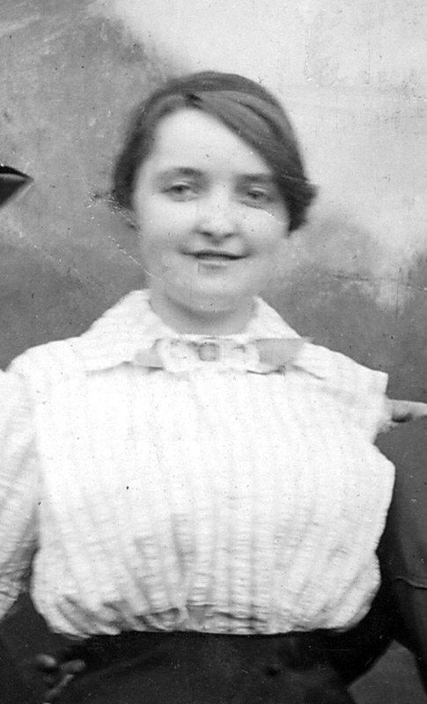
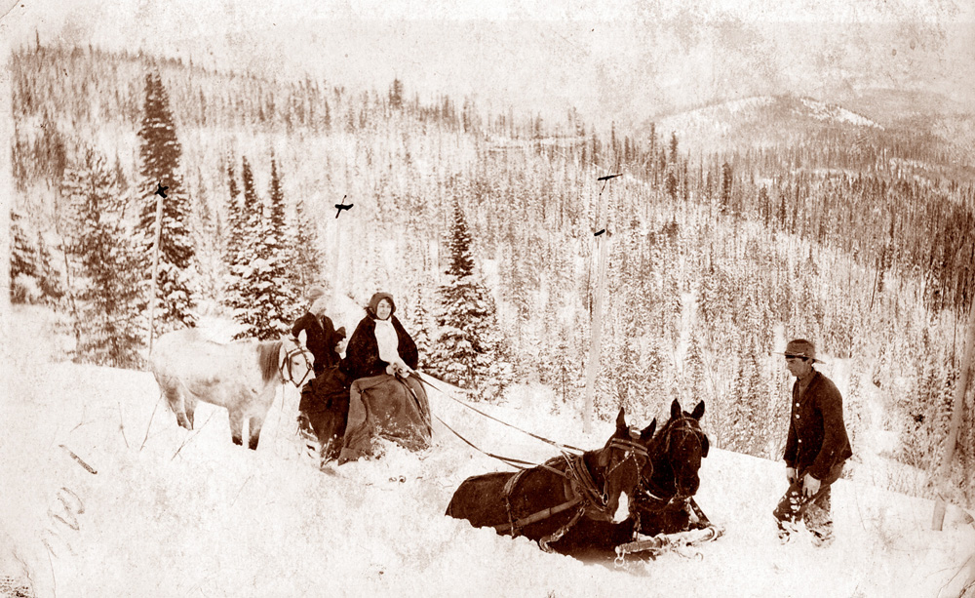
In May, Clint and Mabel moved to the homestead on Red River he’d bought some time before. It was occupied by an old guy who wasn’t able to prove up on it, so Clint had made a deal, allowing the old man to continue living in the small cabin until Clint and his bride arrived. On the way out to the homestead, Clint rode horseback, breaking trail through the snow ahead of Mabel’s sled. But the sled overturned near Mountain House and spilled Mabel into the snow. Clint came riding back, worried because his bride seemed to be crying, but he found her lying in the snow, giggling.

The next December, Clint took his pregnant wife to Pleasant Valley (below Clearwater) for the birth of their first child. Berta Mae was born there on 16 Dec 1914. In their first years on Red River, Clint and Mabel’s family grew rapidly. Berta Mae was joined by Clinton Winfield (“Bill”) on 21 Jan 1916; Richard Donald on 12 May 1917; James Edgar on 16 Oct 1918; Ned Finley, born in Stites on 5 Jun 1920; Robert Wren on 8 Oct 1921; and Fred Elvin on 13 Apr 1923.

Clint started building a large log home (which is still standing next to the Red River Road) in 1924, but it wasn’t ready for occupancy in time for Paul Benjamin’s birth on 20 July 1925. He was the last child born in the little cabin.

The family moved into the new home in 1926. The last of the Gibler children, Sara Jo, was born there 16 Apr 1927. The walls of the house were insulated only with building paper and the temperature in the bedroom dropped to freezing while Mabel was in labor. Sara Jo’s was a breech birth, and very difficult. After Mabel had been in labor for 22 hours, Clint sent to Elk City for an experienced midwife. Mabel dislocated a hip during delivery, and got around for the next several weeks by propping her bad leg on a chair and pushing it around. Then she was taken to Colfax for surgery. That was the end of child-bearing for Mabel; nine was enough!

(Later, someone noted the nine children and asked Mabel if she and Clint were Catholics. She replied, “No, we’re just careless Protestants.”)

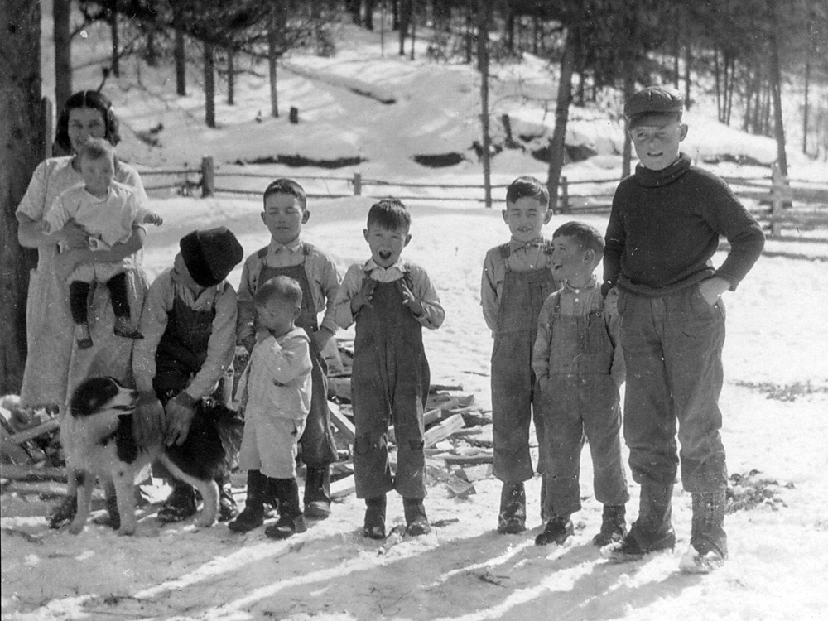
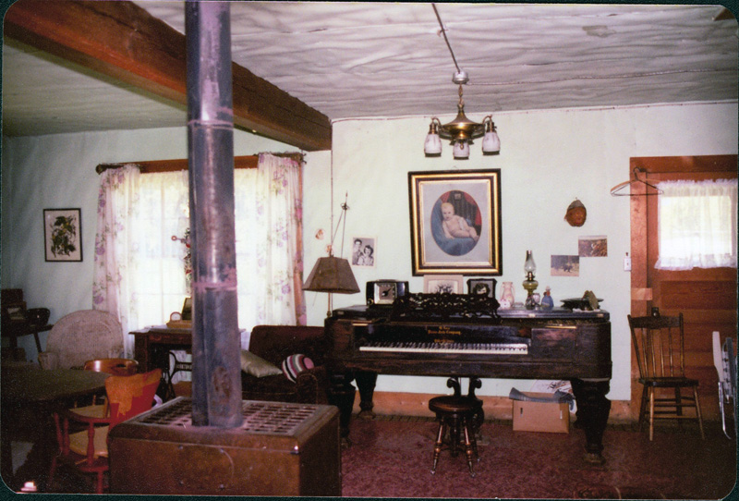
During the later stages of house-building, Clint and Mabel got Earl Skooglar to come up and hew the big beams for their house. Earl had a guy named Bruegeman working with him. The work was somewhat slowed by the fact that every time the two hewers laid down a tool, one of the seven Gibler boys would run off with it.

In the early years on Red River, Indians would often pass by the ranch on their way to or from hunting areas along the Southern Nez Perce Trail. Sometimes Mabel would be startled to look up and find an Indian staring silently through the window. She learned to be friendly and offer them something to eat or drink.
There were also very many freighters on the road, hauling supplies to Dixie and to the mining camps. These were tough but generally good men. One time Clint got to wrestling with another freighter in the upstairs sleeping area of a way station. When the other guy got mad, Clint threw him down the stairs, causing him to break his leg. They remained good friends even so.

When the Giblers arrived on Red River, there were no elk. But one day a few years later, Clint came quickly into the house to get his rifle. “The biggest deer I ever saw is outside,” he said. “I don’t know what it is, but it’s BIG!” He had just seen his first elk. After that, there were more and more on the ranch. The elk herds that had been shot out by the early waves of miners had restored themselves with the help of game laws and the extra forage that grew in the aftermath of the 1910 wildfires.

Clint raised cattle on the ranch, butchered them, and sold the meat to the mine cook shacks. He was a good butcher. He’d make a point of shooting a cow near a tree, so he could hoist it immediately and skin it and clean it off the ground, where it wouldn’t get dirty.

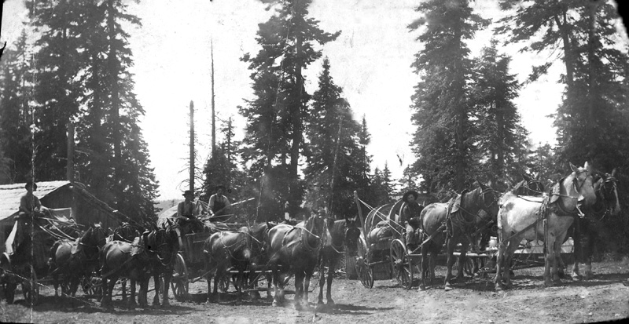
After a while, Clint had the mail contract for Dixie. He made this run in every kind of weather imaginable, determined to get the mail through on time, no matter what. Once in a blizzard the horses couldn’t make it over Dixie Summit. Clint left his horses at a spring called “the watering hole” and walked the rest of the way on snowshoes, carrying the mail sack over his shoulder. It took him 26 hours to go the remaining 6 miles. He knew that if he stopped to rest, he would freeze to death, so he kept going until he made it.

Another time when he crossed Dixie Summit with one horse on snowshoes, he was met by six hungry wolves. As usual, he didn’t have a gun, and besides, he thought there were too many wolves to shoot. So he mounted his horse and rode to Dixie as fast as the horse could go on its snowshoes. They made it again.

Berta Mae went with her Dad on the Dixie run one winter. She got so cold she thought she’d freeze. When they arrived in Dixie, they were met by a guy with a dog team and sled, who invited Berta Mae to take a ride. She’d had enough of the cold, and refused the offer.

In those days, Dick Byers was a moonshiner in Dixie. He talked Clint into hauling some product for him. Clint made the mistake of telling Mabel, who hit the roof. Mabel didn’t have any use for alcohol, and furthermore warned Clint that if the authorities discovered he was carrying Byers’ moonshine, Clint would lose his mail contract. Clint took Mabel’s advice and stopped carrying Byers’ goods.

Clint sang Scotch songs all the time, in the style of Harry Lauder. He sang on the trail, he sang at home, he sang for parties, sang in bars, sang in schools. He even sang one time on the “Queen for a Day” radio show. They introduced him as “Clint Gibler from Utah.” Clint shot back, “UTAH? Just because I’ve got nine kids, you think I’m from Utah?”

---

Meanwhile, back in Kansas, Ed Gibler’s brother Clint found out there was oil on the property Ed had given him. By the late 1930s, that branch of the family was becoming prosperous from the oil found below the earth as well as the wheat that grew on top of it. The Idaho Giblers thought this was funny. In fact, when a letter would arrive from Kansas, Mabel would say, “Well, we got another Kansas weather report!” The letter would be full of news about Kansas weather and the price of wheat but little else.

---

Clint and Mabel lived into their eighties, mostly in Kamiah and then Lewiston Orchards in later years. Clint died 25 Jan 1972. Mabel lived until 16 Feb 1977. They are buried together in the IOOF section of Kamiah Cemetery.

The Gibler Children

Berta Mae Gibler McLeod, born 16 Dec 1914 in Pleasant Valley, near Clearwater, was raised on the family ranch along Red River. She attended the Red River School through the 11th grade, then finished high school in Kamiah in 1933. She attended the University of Idaho for two years, after which she taught school near Winchester for a year.

Berta married Donald J. McLeod on 6 Apr 1935 at St. Maries. They lived and worked for many years on a farm near Nez Perce. Donald died 17 Sep 1977. Berta died 7 Aug 2002 and is buried in Kamiah with Donald.

Berta and Don had six children: Mary Jane Leitch, Donald McLeod, Jean Lamb, Joan Ritter, Dot Cox, and Scott McLeod.

---
Clinton Winfield “Bill” Gibler, was born 21 Jan 1916. He was a Second Lieutenant, USAAF in WWII; trained as a B-17 bombardier; flew with 8th Air Force, 94th Bombardment Group, 331st Squadron. The plane was shot down over Frankfurt, Germany while on a mission to bomb a synthetic oil refinery in the Sudetenland, 12 May 1944. Bill received a severe wound and was unable to bail out when his plane went down. His remains were reburied in 1951 in Fort McPherson Military Cemetery, Maxwell, Nebraska.

---
Richard Donald Gibler was born 12 May 1917. Dick attended the Red River School, completed high school in Kamiah in 1936, and finally completed business studies at the Northwestern School of Commerce in Portland in 1940.

Dick worked for the War Department in Washington, D.C. during WWII. After the war, he worked in Redmond, OR and San Diego, CA, then returned to north central Idaho. He married Beryl Frazier 13 Sep 1945 in Mollala, OR. Dick and Beryl had four children: Donna Cochran, Duane Gibler, Dwight Gibler, and Deanna Watson. Beryl died in 1997.

Dick was active in Kamiah civic affairs. He helped found the Kamiah Credit Union, the Gold Trail Wranglers, and the Senior Citizens’ Society, and was the founder of the Charles E. Burkhardt Homes, which provided affordable housing for Kamiah’s elderly. During these years, Dick worked as a bookkeeper, Kamiah postmaster, and insurance salesman.

Dick suffered from dwarfism, but took his physical condition with typical Gibler humor. Once when he was going to business college in Portland, he was out walking and encountered a friend who had been maimed in a sawmill accident. He told the friend, “Get on your own side of the street; I’m working this side!” Dick was a musician, too. His instrument was the musical saw.

Dick moved to the Boise area after his wife’s death in 1997. He died 21 Jun 2003 in Meridian and is buried in Kamiah together with Beryl.

---
James Edgar Gibler was born 17 Oct 1918. He was a P-38 pilot in the Pacific during WWII. After the war, he was a provost marshall in Japan. Then he returned home, earned a law degree at the University of Idaho, and joined the FBI, in which he served for many years. Jim died 16 Sep 2006 in San Diego County, California.

---
Ned Finley Gibler was born in Stites, 5 Jun 1920. (His middle name was in honor of the couple who ran the Finley stage station.) Ned attended the Red River School for several years, then completed high school in Kamiah in 1936 when he was almost 16. He worked in Kamiah in a butcher shop until he entered military service in 1940. Ned married Geneva I. Hamilton, of Kamiah, on 30 Mar 1941. He served in the Army Transport Service in Alaska and then as a Merchant Marine in the South Pacific during WWII. After the war, Ned was a butcher and grocer in Grangeville, later owned a store in Kooskia, and still later, was the Kooskia postmaster.

Ned and Geneva raised three sons, Gary, Gene, and Greg. The family was very active in music, and Ned was active in local politics, serving on the Kooskia City Council and as Kooskia Mayor.

Ned died 28 Jan 2002 and is buried in Kooskia.

---
Robert Wren Gibler was born 8 Oct 1921 in Elk City, where the family had moved for the winter. He was born in a little log cabin that stood just downhill from the store; the midwife was B.B. Scott’s wife, Violet.

Bob served as as an aircraft mechanic in the USAAF during WWII. After the war, he entered a veteran’s drawing for land in the Columbia Basin and won a parcel in Warden, Washington. Bob is a life-long bachelor and lives today in Moses Lake.

---
Fred Elvin Gibler was born on 13 Apr 1923 - Friday the Thirteenth. He was a bombardier in the USAAF during WWII. After the war, he married Margaret MacPherson and adopted her two children by a previous marriage. They then had three more children.

Fred took over Clint and Mabel’s farm in Kamiah when they moved to Lewiston Orchards. He started a sand and gravel business and later developed Pine Ridge Subdivision.

---
Paul Benjamin Gibler was born 20 July 1925. Suffered from severe rheumatoid arthritis from an early age, but served briefly in the U.S. Army Air Corps during WWII and later attended the University of Idaho. He began work at Kamiah’s Twin Feather Unit of Potlatch Forests, Inc. in 1948 and eventually became the general plant foreman. He married Donnalene Sredanovich 30 July 1952, and they had two sons and two daughters. Paul died in surgery at the age of 38, November, 1963, and is buried in Kamiah.

---
Sara Jo Gibler Johnson was born at the Gibler Ranch on Red River, 16 Apr 1927, the only one of the nine children to be born in the big ranch house. In 1941, the family moved to Kamiah during the school year so that the kids could attend a better high school. Sara Jo encountered Donald G. Johnson there when they were both 14. They had met briefly on the South Fork just before that, when he and another boy were driving cattle upriver to Elk City. However, they didn’t impress each other until they were in school together in Kamiah in the Fall of 1941. They fell in love and were engaged three years later, in June 1944, just before their senior year and just before Don went to war.

Sara Jo remembers that her father had thought at the end of the Thirties that the U.S. would be drawn into war before long. However, when the family heard about the attack on Pearl Harbor, Mabel exclaimed, “My God! What’s going to happen to my boys?!”

The war interrupted Don’s formal education. He enlisted in the Navy in the summer of 1944, did part of his training at Farragut Naval Base on Lake Pend Oreille and then went to the west coast, where his ship, the destroyer U.S.S. Wiley, was being commissioned. After shake-down cruises and gunnery training, the Wiley sailed for Pearl Harbor, Manila and then Okinawa. The Wiley arrived at Okinawa shortly after the island was secured. She then spent some months before and after the end of the war destroying mines off the coast of China. She touched at points along the China coast and then in Korea before returning the United States.

Meanwhile, Sara Jo was living with Don’s sister, “Frenchy” (Laverna Mae), in Sheridan, Oregon. Don was discharged from the Navy on 6 June 1946 and joined Sara Jo immediately. She was 19 and he was 20. Don had to get permission from his parents to marry in Oregon at such a young age! Don and Sara Jo were married in Sheridan on 9 June 1946.

After their marriage, they lived in Yakima, WA while Don studied carpentry and welding in trade school. Sara Jo worked at Sears and The Donnely Hotel. A year later, they moved to Grange-ville, Idaho, where Don worked for Pearl Dye as a welder and Sara Jo worked at Penney’s and then for Dr. Buttermore. Later, they moved to Kamiah when they were ready to start a family. They built two homes, selling one for a profit, then Don built and repaired homes for others. They bought and operated the DanDee Motel -- that is, Sara Jo operated it while Don worked on the Dvorshak Dam. They then sold the motel and moved to Lewiston, but Don got a job working on the Grand Coulee Dam, so Sara Jo followed him to Grand Coulee, WA. There she learned to be a meat wrapper and worked for a year at Safeway. When Don got a job at Hanford, they moved to Richland. Sara Jo went to school there and studied business management. Her college teacher there had previously taught her as a child at Red River and Kamiah!

Don retired in 1980, and he and Sara Jo built a house and outbuildings on their portion of the Gibler Ranch, in a beautiful hidden valley along Dawson Creek. They still live there in the summers, managing a little tree farm. They winter in the Lewiston Orchards.

---

Robert W. Stewart

Sometime around 1927, a middle-aged prospector arrived and established a claim on the ridge behind and above the Gibler property. He said his name was Robert W. Stewart, and that he was originally from Boston. He seemed to be an educated man, and had worked as a metalworker in Spokane. But now he was a placer miner, and lived more or less as a recluse in his little cabin on the ridge.

However, Stewart was friendly toward the Giblers, and would come down to their place sometimes for meals. Before eating, he would always put his ill-fitting false teeth in his hip pocket. Mabel once asked him, “Do those damn things ever bite you, Bert?” Stewart had a swinging footbridge over the river, and the Gibler children liked to play on it.

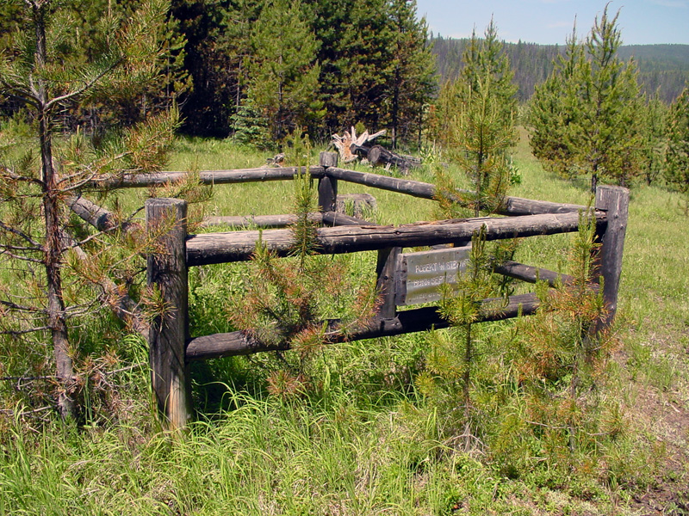
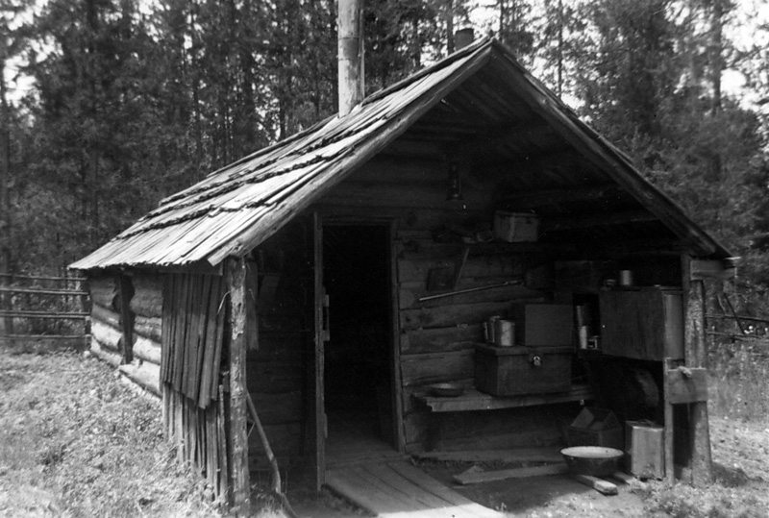
[From a mining record of 24 June 1931: “R.W. Stewart swears that at least $100.00 worth of work or improvements were made upon the Narcissus placer claim during the year, for the purpose of holding said claim for the year ending 1 July 1931.” This was recorded by Mrs. G.L.L. Baskett, the Deputy Recorder for the Elk City Mining District, replacing her late husband.]

Robert W. Stewart lived in his cabin until 1951, when he was taken very ill. Clint and Mabel took him out to the hospital in Grangeville, but old Bert died on 31 July 1951. His remains were brought back to the Gibler Ranch and were buried 75 yards beyond the bridge, on the uphill side, away from the river. Today there is a small fenced plot and a metal sign marking the grave, which is on the edge of a power line right-of-way. The sign says that Stewart was born on 24 Sep 1870.

Robert W. Stewart is listed in the 1930 Census of Elk City. He told the census enumerator that he was 49 years old, that he was born in New York State, and that he was employed as a laborer. His Idaho Death Record is # 003053.

The grave is located at 45° 44’ 2.1” N, 115° 23’ 41.8” W (WGS84).

Sources

- Interviews with Sara Jo Gibler Johnson in June and July, 2005.
- Census enumerations for 1900, 1910, 1920, 1930, obtained through Ancestry.com.
- Family trees obtained from Ancestry.com and FamilySearch.com
- Graves list for Kamiah Cemetery, obtained through RootsWeb.com.
- Obituaries in the Lewiston Tribune archives.
- Clint Gibler’s WWI draft registration card, obtained through Ancestry.com.
- Numerous Gibler family newspaper clippings supplied by Sara Jo Johnson.
- The loss and presumed death of Clinton Winfield (“Bill”) Gibler was confirmed by a National Archives listing for WWII deaths from Lewis County, available at http://media.nara.gov.
- Missing Air Crew Report (MACR) 4826, USAAF, giving details of the loss of Aircraft 42-31704, a B-17G bomber, on a mission to bomb synthetic oil refineries at Brux, Germany (later called Most, Czech Republic) on 12 May 1944. The bombardier on this aircraft was Clinton W. “Bill” Gibler. During a heavy attack by German fighter planes, the bomber lost two engines and part of a wing, and both gas tanks caught fire. Gibler was hit in the knee by 20mm cannon fire, losing a great deal of blood. As a result, he was unable to bail out with other crew members and went down with the plane. One other crew member went down with the plane; the other eight parachuted safely, and were captured and imprisoned until the end of the war.
- Idaho Death Record #003053 for Robert W. Stewart, listing his death at Grangeville, 31 July 1951, found through Ancestry.com. This and the quoted mining record are the only certain records I have been able to find for Stewart. I have been unable to confirm that he was born in Massachusetts, and unable to confirm his whereabouts before he showed up on Red River around 1927.
- Marian S. Sweeney: GOLD AT DIXIE GULCH (Clearwater Valley Publishing, 1982). Stories about Clint and Mabel Gibler.
- Interview with Bob Gibler in July, 2007.

-- Bill Salmon

